PART-B

- With neat diagram explain the application of op-amp as clipper and clamper. (Nov/Dec-2019)( Apr/May-2017).
CLIPPER
- In a clipper circuit a precession diode may be used to clip off a certain portion of the input signal to obtain a desired output wave form.
- There are two types of clippers available
- Positive clipper
- Negative clipper
- POSITIVE CLIPPER
- The below figure shows the positive clipper. The clipping level is determined by the reference voltage V_{ref} and could be obtained from the positive supply voltage V⁺.

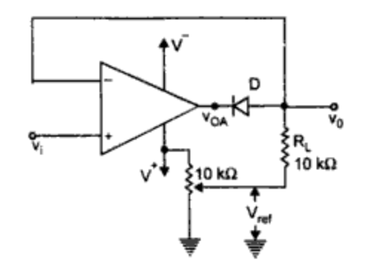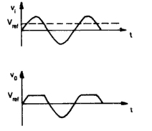
(Positive clipper) (Input output waveforms for positive Vref)
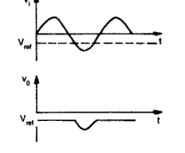
(Input output waveforms for Negative Vref)
- The portion of the output voltage for V₀>V_{ref} are clipped off.
- For input V_{i}<V_{ref} diode D conducts. The op amp works as a voltage follower and output follows the input V_{i} till V_{i}<V_{ref..}

- When V_{i}>V_{ref} the output V_{OA} of the op-amp is large enough to drive D into cut-off. Hence the op-amp operates in open loop and the output voltage V₀=V_{ref}. If the reference voltage is made negative the entire output waveform is clipped off.
NEGTAIVE CLIPPER
- The positive clipper can easily be converted into a negative clipper by simply reversing diode D and changing the polarity of the reference voltage Vref as shown in the figure. The negative clipper clips off the negative parts of the input signal below the reference voltage. 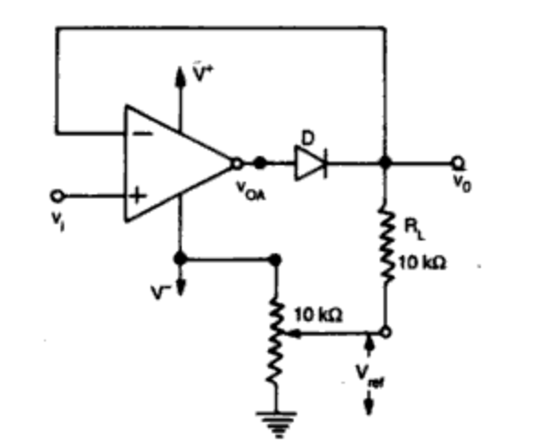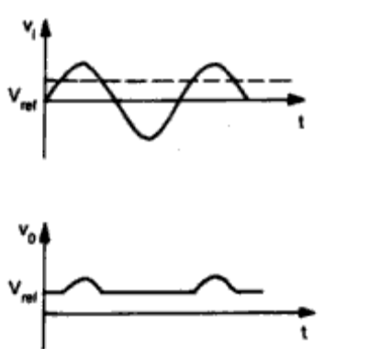
(Negative clipper) (Input output waveforms for positive Vref)
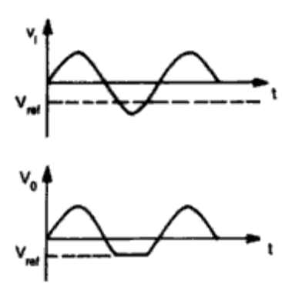
(Input output waveforms for Negative Vref)
CLAMPER
- The clamper is also known as dc inserter or restorer.
- The circuit is used to add a desired dc level to the output voltage that is the output is clamped to the desired dc level.
- The two types of clamper are
    - Positive clamper
    - Negative Clamper

- The figure below shows a clamper with a variable positive dc voltage applied to the (+) input terminal. The circuit clamps the peaks of the input waveform and therefore is also
called a peak clamper.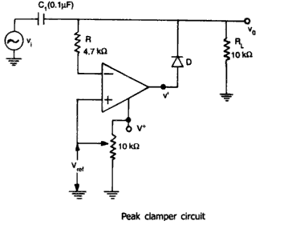
- Considering the ac input signal V_{i}=V_{m}sinωt applied at the (-) input terminal. During the negative half cycle of V_{i} diode D conducts. The capacitor C₁Charges through diode D to the negative peak voltage V_{m}.
- During the positive half cycle of V_{i} diode D reverse biased. The capacitor retains its previous voltage V_{m}.
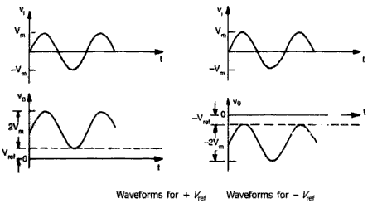
- The input and output wave forms shown above. It is possible to obtain negative peak clamping by reversing the diode D and using a negative reference voltage.
- The use of resistor provided in the circuit is to protect the op-amp against excessive discharge currents form capacitor when the dc supply voltages are switched off.
- Explain the working of Successive approximation type ADC. (Nov/Dec-2019)

The successive approximation technique uses a very efficient code search strategy to complete n-bit conversion in just n-clock periods.An eight bit converter would require eight clock pulses to obtain a digital output.The circuit uses a successive approximation register (SAR) to find the required value of each bit by trial and error. The circuit operates as follows.With the arrival of START command, the SAR sets MSB d₁ = 1 with all other bits to

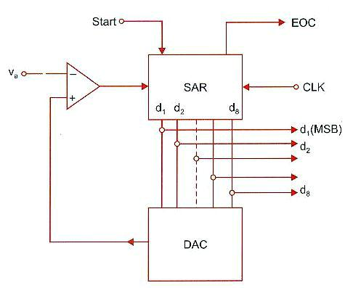

zero so that the trial code is 1000 0000. The output V_{d} of the DAC is now compared with analog input V_{a.}
The successive approximation technique uses a very efficient code search strategy to complete n-bit conversion in just n-clock periods.An eight bit converter would require eight clock pulses to obtain a digital output.The circuit uses a successive approximation register (SAR) to find the required value of each bit by trial and error. The circuit operates as follows.With the arrival of START command, the SAR sets MSB d₁ = 1 with all other bits to zero so that the trial code is 1000 0000. The output V_{d} of the DAC is now compared with analog input V_{a.}
- If V_{a} is greater than the DAC output V_{d ,} then 1000 0000 is less than the correct digital representation. The MSB is left at ‘1’ and the next lower significant bit is made ‘1’ and further tested.
- However, if V_{a} is less than the DAC output V_{d ,} then 1000 0000 is greater than the correct digital representation. So reset MSB to ‘0’ and go on to the next lower significant bit.This procedure is repeated for all the subsequent bits, one at a time, until all bit positions have been tested.Whenever the DAC output crosses V_{a,} the comparator changes state and this can be taken as the End Of Conversion (EOC) command. The conversion sequence is given as follows

Correct Digital Successive approximation register output V_{d} Comparator
Representation at different stages in the conversion Output

1101 0100 1000 0000 1 (initial o/p)
1100 0000 1
1110 0000 0
1101 0000 1
1101 1000 0

1101 0100 1
1101 0110 0
1101 0101 0
1101 0100
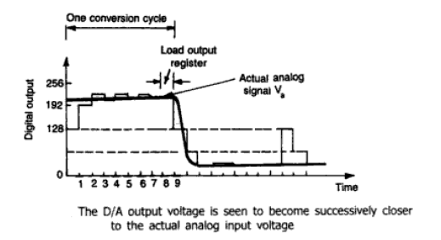
- From above figure it can be seen that D/A output voltage becomes successively closer to the analog input voltage.
- It requires eight clock pulses to establish the accurate output regardless of the value of the analog input. However, one additional clock pulse is used to load the output register and reinitialize the circuit.

- Draw the Sample and Hold Circuit and explain its operation.

SAMPLE AND HOLD CIRCUIT(S/H):
- A Sample and Hold circuit samples an input signal and holds on its last sampled value until the input is sampled again.
- The main application of S/H circuits are
    - Digital interfacing
    - Analog to digital conversion
    - Pulse code modulation
- The S/H circuit shown below having the n-channel E-MOSFET works as a switch and is controlled by the control voltage V_{C} and the capacitor C stores the charge.
The analog signal V_{i} to be sampled is applied to the drain of E-MOSFET and the control voltage V_{C} is applied to the gate. When V_{C} is positive the E-MOSFET turns on and the capacitor C charges to the instantaneous value of the input with a time constant value of [(R₀+r_{DS}(on)]C.
- Here R₀ the output resistance
- r_{DS} is the resistance of the MOSFET when On.
- The time period T_{S}, the time during which the voltage across the capacitor is equal to the input voltage is called sample period.
- The time period T_{H} of V_{C} during which the voltage across the capacitor held constant is called hold period.

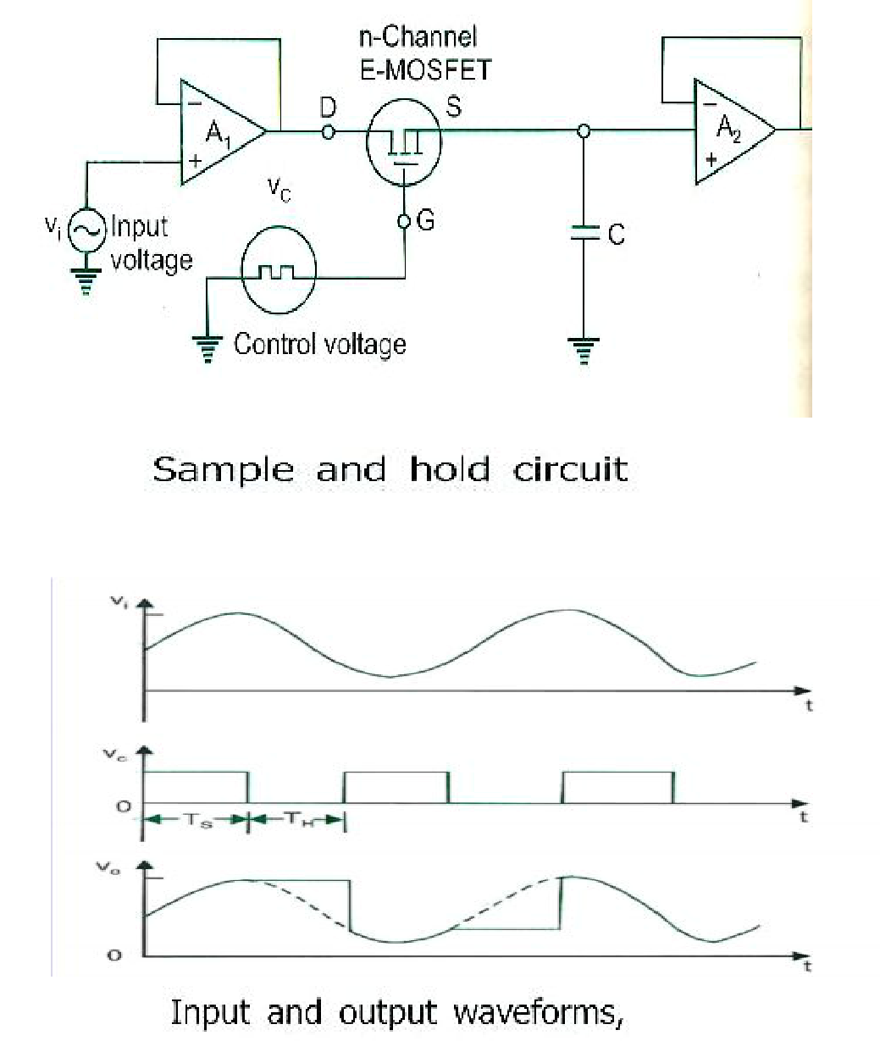

4.Explain the operation of Instrumentation amplifier. (AU-Nov/Dec 2014) (AU-Apr/May 2018)
- In a number of industrial and consumer applications, one is required to measure and control physical quantities. Some typical examples are measurement and control of temperature, humidity, light intensity, water flow etc. these physical quantities are usually measured with help of transducers.
- The output of transducer has to be amplified so that it can drive the indicator or display system. This function is performed by an instrumentation amplifier. The important features of an instrumentation amplifier are
- high gain accuracy
- high CMRR
- high gain stability with low temperature coefficient
- low output impedance
There are specially designed op-amps such as μA725 to meet the above stated requirements of a good instrumentation amplifier.
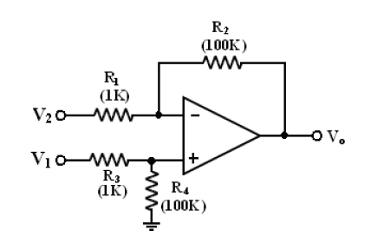
The above circuit is a basic instrumentation amplifier. The output voltage, V₀ is given by
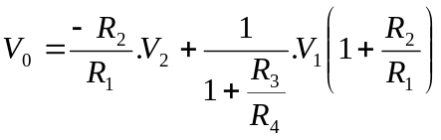
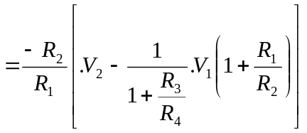
For 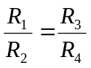, we obtain
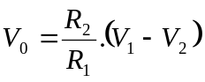 -------------- (1)
- The source V₁ sees an i/p impedance of R₃+R₄ (101kΩ) and input impedance seen by source V₂ is only R₁ (1kΩ)
- This low impedance loads the signal source heavily.
- So a high impedance buffer is used preceding each input to avoid the loading effect.
Consider the following where Op-Amps. A₁ and A₂ have differential input voltage as zero.

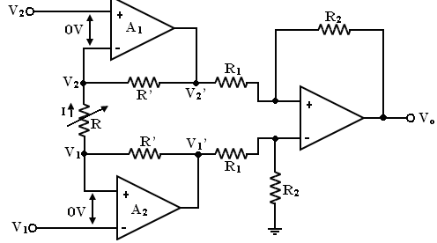
- Under common mode condition i.e., for V₁ = V₂, the drop across R is zero.
- No current flows through resistor R and R¹. So non-inverting amplifier A₁ acts as voltage follower, hence V₂ = 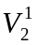.Similarly, A₂ acts as voltage follows having output 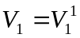
- If 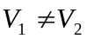, then current flows through R and R¹ and 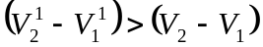.Thus the circuit has high CMRR and high differential gain.
- The voltage at (+) input terminal of Op-amp A₃ is 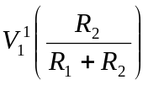. Using superposition theorem,
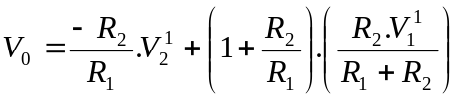

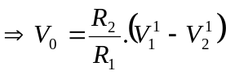 -------------- (2)
current passing through R is given by
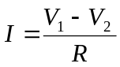 -------------- (3)
The same current flows upwards through R¹ since op-amp i/p current is zero.
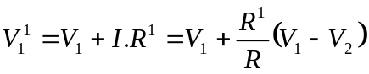 -------------- (4)
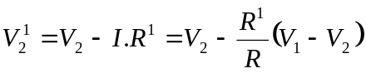 -------------- (5)
Substituting equations (4) and (5) in equation (2), we get
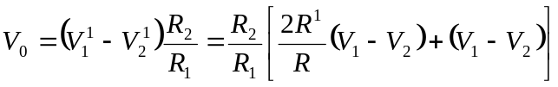
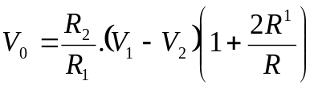

 --------------- (6)
Instrumentation Amplifier using Transducer Bridge

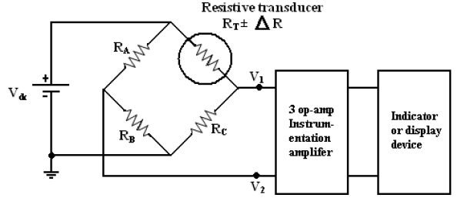
The above circuit uses a resistive transducers whose resistance changes as a function of physical quantity to be measured.
- The bridge is initially balanced by a D.C supply V_{dc}. So that V₁ = V₂.
- As the physical quantity changes, the resistance R_{T} also changes, causing an unbalance in the bridge i.e.,
- This differential voltage now gets amplified by the three Op-Amp differential instrumentation amplifiers and output is given to display device.

- Explain the operation of peak detector circuit.
PEAK DETECTOR:
- The Square, Triangular, Sawtooth and pulse waves are typical examples of non-sinusoidal waveforms. A conventional ac voltmeter cannot be used to measure these sinusoidal waveforms because it is designed to measure the rms value of the pure sine wave.
- One possible solution to this problem is to measure the peak values of the non-sinusoidal waveforms. Peak detector measures the +ve peak value of the square wave input.
- The circuit follows the voltage peaks of a signal and stores the highest value on a capacitor.
- If a higher peak signal value comes along, this new value is stored. The highest peak value is stored until the capacitor is discharged.
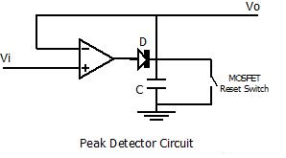
- Considering the above circuit when input exceeds the voltage across the capacitor, the diode is forward biased and the circuit becomes a voltage follower. When input voltage drops below the voltage across the capacitor, the diode becomes reverse biased and the capacitor holds the charge till input voltage again attains a value greater than voltage across the capacitor.
- Voltage wave shape for the positive peak detector is given below.

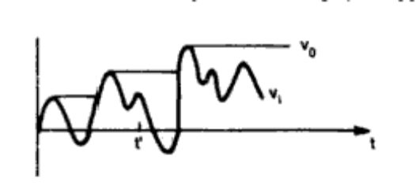
- The application of peak detector is test and measurement instrumentation, Amplitude
Modulation.
- Explain the operation of a square wave generator by drawing capacitor and voltage waveforms. (Or)Draw the circuit diagram of Astable multivibrator using Op-Amp and explain its operation. (Nov/Dec-13)

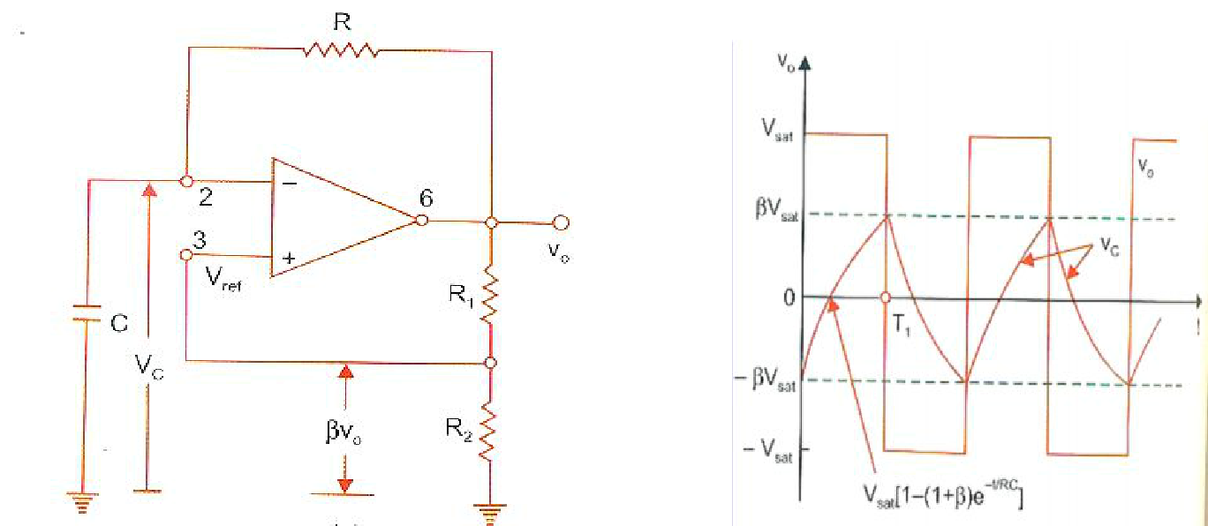

 
It is also called as free-running oscillator; the principle of operation of square wave output generation is to force an Op-amp to operate in the saturation region.

- Output is also feedback to (-) input terminal after integrating by means of low pass RC combinations.

- The reference voltage is .V₀ and it takes value from +.V_{sat} and -.V_{sat.}

- It has two quasi stable states (no stable state). Thus there is oscillation between these two states and no external signals are required to produce the change in state.

- Whenever, the input at inverting (-) terminal exceeds V_{ref} switching takes place resulting in square wave output.

- Consider instant of time when output V₀ is at +V_{sat}.

- Capacitor starts to charge towards +V_{sat} through resistance R.

- Voltage at non-inverting (+) terminal is at +.V_{sat} by R₁ and R₂ combination.

- When voltage at (-) terminal is just greater than reference voltage +.V_{sat}, the output is driven to –V_{sat.}

- At this time the capacitor voltage is at +.V_{sat.}

- It begins to discharge through R to –V_{sat}

- When V_{C} is more negative than-.V_{sat} the output again switches to +V_{sat.}

- The frequency is determined by time it takes for the capacitor to charge and discharge between +V_{sat} and –V_{sat.}

- The peak-to-peak output amplitude can be varied by varying the power supply. But the better technique is to use back-to back zener diodes.

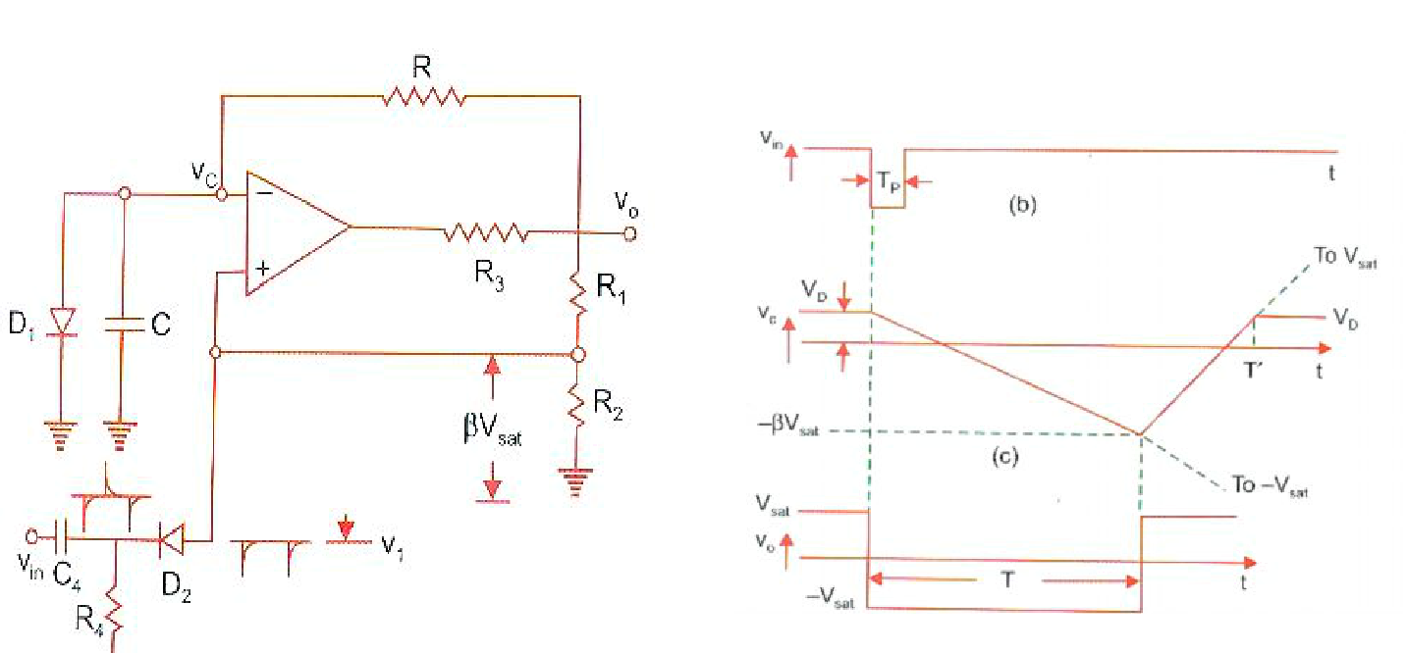
- Explain the operation of Monostable Multivibrator with neat circuit diagram. (Nov/Dec-07)

- It is also know as One-shot Multivibrator or Monoshot since it produces a single pulse of specified duration in response to each external trigger signal.
- There is only one stable state. When an external trigger is applied, the output changes its state to a new state, called quasistable state.

- The circuit remains in this state for a particular fixed time interval. After sometime, it returns back to its original stable state.
- In fact an internal trigger is generated to drive the circuit to its original state. Changing and discharging of capacitor provides the internal trigger signal.
- The diode D₁ clamps capacitor voltage to 0.7 V, when the output is at +V_{sat} A negative going pulse of magnitude V₁ is applied to differentiator R₄C₄ and diode D₂ gives negative going triggering impulse to (+) input terminal

- Assume in stable state that V₀ is at + V_{sat}

- Diode D₁ conducts and capacitor voltage, V_{C} gets clamped to 0.7 V. Voltage at (+) input terminal through R₁R₂ is +.V_{sat .}
- Negative trigger of magnitude V₁ is applied to (+) terminal so effective signal at this terminal is less than 0.7 V V _{sat}  (V₁ ) 0.7v, the output of Op-Amp will switch from +V_{sat} to –V_{sat}.
- The diode will now get reverse biased and the capacitor starts charging exponentially to –V_{sat} through R.
- When capacitor voltage become more negative then -V_{sat}, the output switches to

+Vsat
- Now capacitor, C, changes towards +V_{sat} until V_{C} is 0.7 V as it gets clamped to the voltage.
- The general solution for a single time constant low pass RC circuit with V_{i} and V_{f} as initial and final values is

8. Describe the working of a weighted Resistor type DAC. (AU-Nov/Dec-2016) (AU-May/Jun-2014)

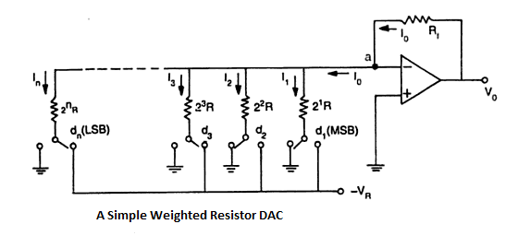
- The above circuit uses a summing amplifier with a binary weighted resistor network. The op-amp is connected in inverting mode it can also be connected as non-inverting mode.
- The op-amp is simply working as a current to voltage converter.
- The polarity of the reference voltage is chosen accordance with the type of switch used. For example, for TTL compatible switches, the reference voltage should be +5 V and the output will be negative.
- It has n electronic switches d₁, d_{2,}…, d_{n} controlled by binary input word. These switches are of Single Pole Double Throw (SPDT) type.
- If the binary input to a particular switch is ‘1’, it connects the resistance to the reference voltage -V_{R.}
- If the binary input is ‘0’, the switch connects the resistance to the ground.
- The output current for an ideal Op-Amp is
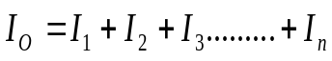
= 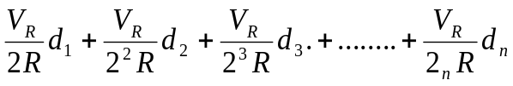
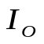= 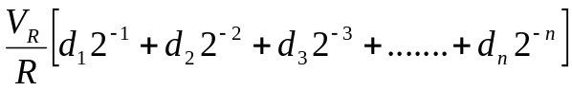
- The output voltage is given by,
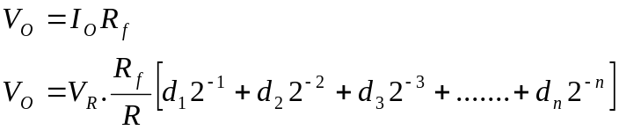
- If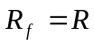,
- For example consider the digital input 1 0 0. Here d₁ = 1, d₂ = 0, d₃ = 0.Now the output voltage is given as,
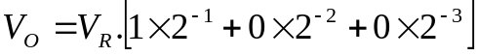
= 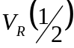
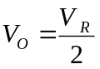
The Transfer characteristics of a 3-bit DAC is given below.
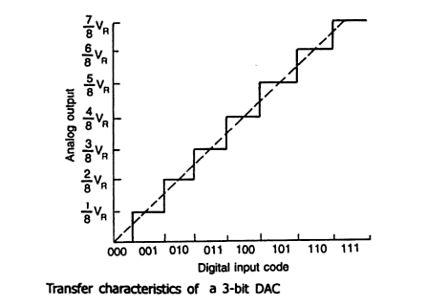
Disadvantages of Binary Weighted DAC :
- Wide range of resistor values is required. For a 8-bit DAC, the resistors required are 2¹R, 2²R, 2³R…...,2⁸R. Therefore, the largest resistor value is 128 times the smallest one. This restricts the use of binary weighted resistor DAC’s below 8-bits.
- It is impracticable to fabricate large values of resistor in IC and voltage drop across such a resistor due to bias current also affects accuracy. For smaller values of resistors the loading effect may occur.

- Describe the working of a R-2R type DAC. (AU-Nov/Dec-2014) (AU-Nov/Dec-2013

- The problem of using a wide range of resistor values can be solved by using the R-2R ladder type DAC.
- This method is well suited for integrated circuit realization. The typical value of ranges from 2.5kΩ to 10kΩ.
- Consider a 3-bit DAC where switch positions d₁, d_{2,} d₃ correspond to binary word 1 0 0.
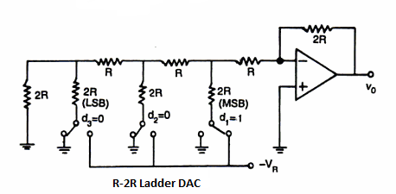
- The original circuit can be simplified to the equivalent circuit as shown below.
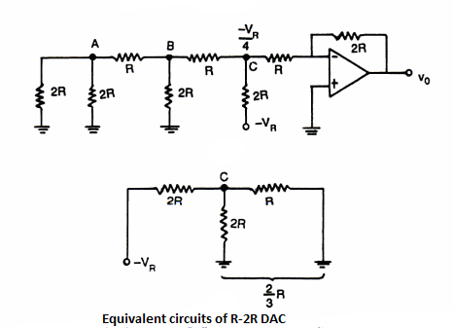
- Voltage at node C is given by,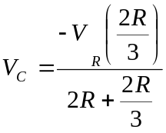
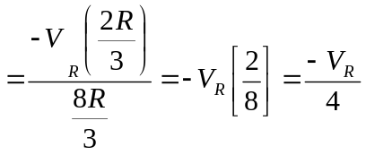
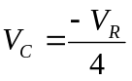
Considering the Op-Amp to be an inverting amplifier, the output voltage is given as,
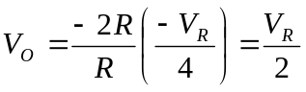

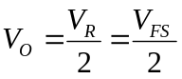 Where,
- V_{R} → Reference voltage
- V_{FS}→ Full Scale voltage
For example the binary word 001 in 3bit DAC and its equivalent circuit is is shown in fig.
The output voltage of the 3 bit DAC is calculated as
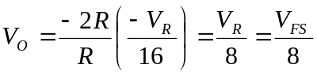
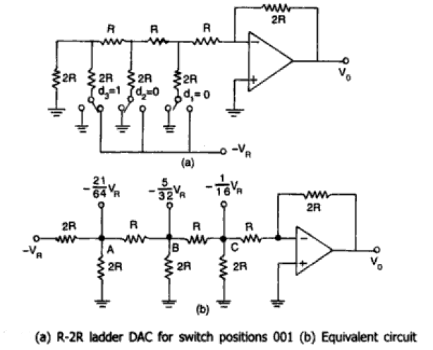
Advantages:
- As we need resistors of only two values (R and 2R), it is easier to build this circuit with high accuracy and stability.
- We can increase the number of bits just by adding more sections of same R-2R values.
- With neat sketch explain the working of a flash type ADC. (AU-Nov/Dec-2014)

Flash type ADC (or) Parallel comparator ADC is the simplest possible A/D converter. Figure shows the 3-bit A/D converter. The circuit consists of a resistive divider network, 8 op-amp comparators and a 8-line to 3-line encoder (3-bit priority encoder).
At each node of the resistive divider, a comparison voltage is available.Since all the resistors are of equal value, the voltage levels available at the nodes are equally divided between the reference voltage V_{R} and the ground.

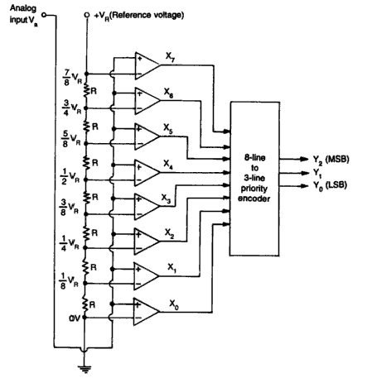
Fig: Basic circuit of a Flash type A/D Converter
- The purpose of the circuit is to compare the analog input voltage V_{a} with each of the node voltages. The truth table for the flash type ADC is shown in figure.
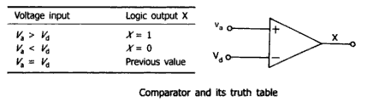
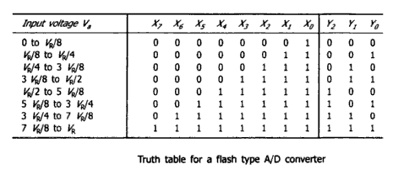

Advantages of Flash type ADC
- The circuit is having the advantages of high speed as the conversion takes place simultaneously rather than sequentially.
- Typical conversion time is 100 ns or less.
- Conversion time is limited only by the speed of the comparator and of the priority encoder.
Disadvantages of Flash type ADC
- The circuit is having the disadvantage that the number of comparators required almost doubles for each added bit.
- A 2-bit ADC requires 3 comparators, 3-bit ADC needs 7, where as 4-bit requires 15 comparators. In general the number of comparators required are 2^{n}-1, so for larger value of n, produces complexity for the priority encoder.

- Explain the working of a Dual slope type A/D converter? (AU-Apr/May-2018) (AU-Apr/May-2017)
- In Dual-Slope ADC Figure (a) shows the functional diagram of the dual-slope or dual-ramp converter. The analog part of the circuit consists of a high input impedance buffer A₁ precision integrator A₂ and a voltage comparator.
- The converter first integrates the analog input signal V_{a} for a fixed duration of 2^{n} clock periods as shown in Fig.(b). Then it integrates an internal reference voltage V_{R} of opposite polarity until the integrator output is zero.
- The number N of clock cycles required to return the integrator to zero is proportional to the value of V_{a} averaged over the integration period. Hence N represents the desired output code. The circuit operates as follows;
- Before the START command arrives, the Switch SW₁ is connected to ground and SW ₂ is closed. Any offset voltage present in the A_{l} , A₂, Comparator loop after integration, appears across the capacitor C_{AZ} till the threshold of the comparator is achieved. The capacitor C_{AZ} thus provides automatic compensation for the input-offset voltages of all the three amplifiers.

- When SW₂ opens, C_{AZ} acts as a memory to hold the voltage required to keep the offset nulled. At the arrival of the START command at t = t₁ the control logic opens SW₂ and connects SW₁ to V_{a} and enables the counter starting from zero.

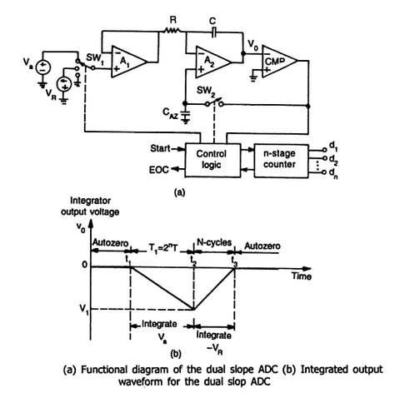
- The circuit uses an n-stage ripple counter and therefore the counter resets to zero after counting 2^{n} pulses. The analog voltage V_{a} is integrated for a fixed number 2^{n} counts of clock pulses after which the counter resets to zero.
- If the clock period is T, the integration takes place for a time T₁=2^{n} x T and the output is a ramp going downwards as shown in Fig.(b)
- The counter resets itself to zero at the end of the interval T₁ and the switch SW₁ is connected to the reference voltage (-V_{R}). The output voltage V₀ will now have a positive slope. As long as V₀ is negative, the output of the comparator is positive and the control logic allows clock pulse to be counted.
- When V₀ becomes just zero at time t = t₃, the control logic issues an end of conversion (EOQ )command and no further clock pulses enter the counter. It can be shown that the reading of the counter at f₃ is proportional to the analog input voltage V_{a}.
- In fig(b)
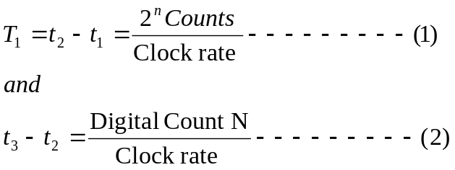

- And for an integrator
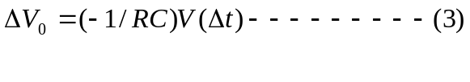The voltage V₀ will be equal to V₁ at the instant t₂ and can be written as,
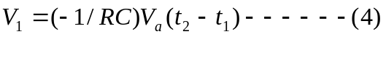
- The voltage V₁ is also given by,
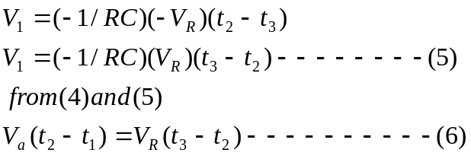
- Putting the values of (t₂-t₁)=2^{n} and (t₃-t₂)=N we get

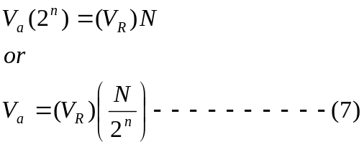
- The following important observations can be made:
- Since V_{R} and n are constant, the analog voltage V_{a} is proportional to the count reading N and is independent of and T.
- The dual-slope ADC integrates the input signal for a fixed time, hence it provides excellent noise rejection of ac signals whose periods are integral multiples of the integration time T.
- The main disadvantage of the dual-slope ADC is the long conversion time.
APPLICATIONS:
Dual-slope converters are particularly suitable for accurate measurement of slowly varying signals, such as thermocouples and weighing scales. Dual-slope ADCs also form the basis of digital panel meters and millimeters.
- Explain the working of a Single slope type A/D converter. (AU-Apr/May-2018)
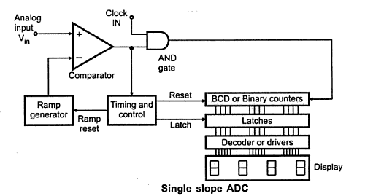

- At the start, the RESET signal is provided to the ramp generator and the counters. Thus the counters are reset to 0’s.

- The analog input voltage V_{in} is applied to the positive terminal of the comparator. As this is more positive than the negative input, the output of the comparator goes HIGH.
- The output of the ramp generator is applied to the negative terminal of the comparator. The HIGH output of the comparator enables the AND gate which allows CLOCK pulse to reach to the counters and also this high output starts the ramp.
- The ramp voltage goes positive until it exceeds the input voltage. When it exceeds V_{in,} comparator output goes LOW. This disables the AND gate which in turn stops the CLOCK to the counters.
- The control circuitry provides the latch signal which is used to latch the counter data.
- The RESET signal resets the counters to 0’s and also resets the ramp generator. The latched data is then displayed using decoder and a display device.
ADVANTAGES:
- Linear conversion from voltage to time or frequency.
- The output is unaffected by any sudden changes in input.
LIMITATIONS:
- Its resolution is less. Hence for the applications which require resolution of 9 parts in 20,000 or more, this ADC is not stable.
- Variations in ramp generator due to time, temperature or input voltage sensitivity also cause a lot of problems.

- Explain the working of Inverted R-2R ladder DAC. (AU-Nov/Dec-2016) (AU-Nov/Dec-2011)
- The main disadvantage of weighted resistor DAC and R-2R ladder type DAC is that current flowing in different resistors will not remain constant.
- These currents will change with change in digital input of DAC. This causes more power dissipation in resistors carrying more current, which in turn causes heating of resistors.
- The resistance value changes due to heating which will introduce non-linearity error in DAC. This problem can be solved by using the “Inverted R-2R Ladder” type DAC.
- This circuit is called as Inverted R-2R Ladder DAC because the positions of MSB and LSB in the original R-2R ladder type DAC have been interchanged.
- This circuit is also called as “Current mode R-2R ladder type DAC” as the circuit operates on ladder currents.
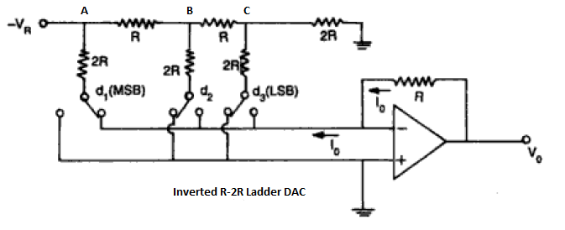

- In this circuit each input binary word connects the corresponding switch to either ground or to the inverting terminal of the Op-Amp which is at virtual ground
- Thus both the terminals are at ground potential. Hence the currents flowing through the resistors will remain constant and it is independent of the input binary word.
- Another important property of this circuit is the total current gets divided equally at each node.
- Hence the current in each branch is constant. So the ladder node voltages also will remain constant, independent of the binary input.
- The node voltages will be,
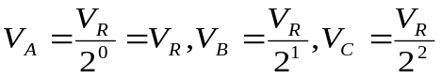
- The various currents are given as,
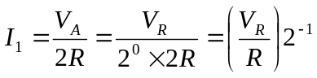 ----------------- (1)
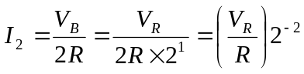 ----------------- (2)
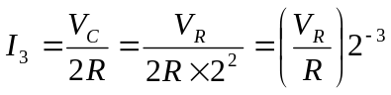 ----------------- (3)
- The output current is given as,
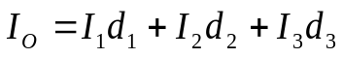 ----------------- (4)
- Substituting the equations (1), (2), (3) in equation (4) we get,
= 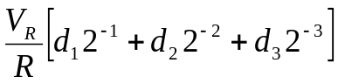 ----------------- (5)
- The output voltage is given by,
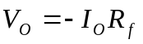 ------------------ (6)
- Substituting equation (5) in (6) we get,
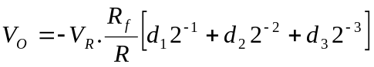
- If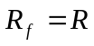

ADVANTAGES:Due to constant node voltages, stray capacitances cannot produce slow down effects on the performance of DAC.

- .What is the purpose of high speed sample and hold circuit? Sketch such a circuit and explain. Also name the parameters associated with it. (AU-Nov/Dec-2011)
- This circuit contains JFET being used as switch. During the sampling time the JFET switch is turned ON and the holding capacitor charges up to the level of the analog input voltage.
- At the end of this short sampling period, the JFET switch is turned OFF. This isolates the holding capacitor C_{H} from the input signal.
- As a result, the voltage across the capacitor C_{H} and hence the output voltage will remain essentially constant at the value of the input voltage at the end of the sampling time.
- However, there will be small drop-off or drop of the capacitor voltage during the holding period due to various leakage currents. To avoid this, the input and output buffers (voltage follower) circuits are used.

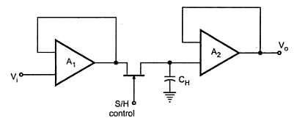

- The above figure shows the open loop architecture of the sample and hold circuit. Open loop S/H circuits are faster than closed loop types which have delayed output feedback to the input buffer.
- However, closed loop architectures provide higher d.c accuracy because of this feedback, canceling the output amplifier offset errors.
- The Acquisition time of an S/H circuit is the time required for the holding capacitor C_{H} to charge up to a level close to the input voltage during sampling. The acquisition time should be as low as possible. Three principle factors which control acquisition time are
  - RC time constant, where R is the r_{ds(ON)} , that is ON resistance of JFET and C is the holding capacitance C_{H}
  - Maximum output current
  - Slew rate of the Op-Amp.

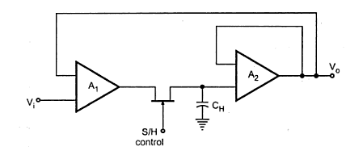
- The circuit shown in above fig offers some advantage over that of first circuit in terms of the acquisition time since the r_{ds(ON)} , i.e. ON resistance of JFET switch is in feedback loop of A1 and A_{2.}

- Therefore the acquisition time for this circuit is limited by only two factors namely, the maximum output current and slew rate of the op-amp.
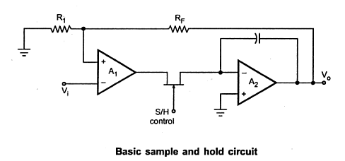
- The circuit shown in above fig performs in a fashion similar to the second circuit but it offers the additional feature of providing voltage gain, The voltage gain of this circuit can be given as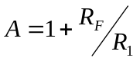. Therefore, the sampled output voltage is equal to the sampled input voltage multiplied by the voltage gain factor of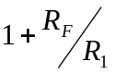.
- The faster capacitor charging rate provides shorter acquisition time. This is because the voltage at the inverting input terminal of A₂ is equal to the capacitor voltage divided by the open loop gain of A₂.
- In this circuit the summing input A₂ remains at virtual ground. Due to this charge removed from the summing junction via C_{gd} is constant regardless of the input and output signal levels.

Performance parameters of S/H circuits
- The performance parameters of S/H circuits are Acquisition time, Aperture time, Aperture uncertainity, Hold mode setting time, hold step, Feed through, Voltage drop.

- Explain the working of monostable multivibrator. (AU-Nov/Dec-2013) (AU-CBE-Apr/May-2011) (AU-CBE-Nov/Dec-2011) (AU-CBE-May/Jun-2010)

The 555 timer connected for monostable operation and its functional diagram is shown below.

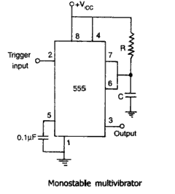

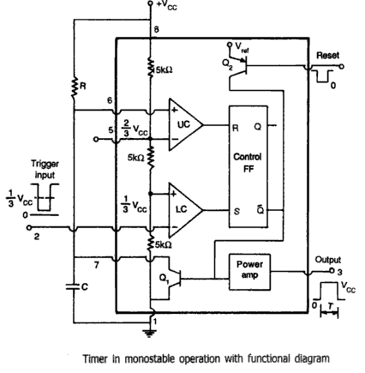
- In the stable state, FF hold transistor Q₁ ON, thus clamping the external timing capacitor C to ground. The output remains LOW.
- As the trigger passes through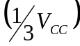, the FF is set, i.e. 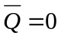. This makes transistor Q₁ OFF and short circuit across the timing capacitor C is released.

- As, output goes HIGH (=V_{CC}).Now the voltage across C rises exponentially through R towards V_{CC} with time constant RC.

- After a predefined time period T, the capacitor voltage is just greater than 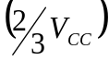 and the upper comparator resets the FF (R=1, S=0). This makes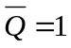, and transistor Q₂ goes ON, thereby discharging the capacitor C rapidly to ground potential.

- The output returns to stable state. The voltage across the capacitor is given as,

    - 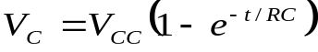 ------------------ (1)
- At t =T, 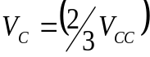 ------------------ (2)
- Equating equations (1) and (2) we get,

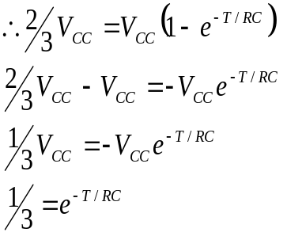
- Taking natural logarithm on both sides,
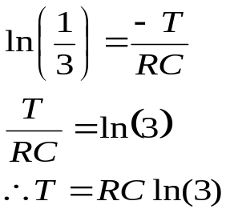
T = 1.1 R.C (Seconds)
- The timing interval is independent of the supply voltage. Also once triggered the output remains HIGH state until time T is completed, which depends only on R and C.
- Any additional trigger pulse coming during this time will not change the output state. However if negative going reset pulse(as in fig d) is applied to pin 4 during the timing cycle, the transistor Q₂ goes OFF, Q₁ becomes ON timing capacitor C is immediately discharged.
- The output now will be as in fig e. it may be seen that the output of Q₂ is connected directly to the input of Q₁ so as to turn on Q₁ immediately and thereby avoid the propagation delay through the FF.

- Even if the reset is released the output remains LOW until a negative going trigger pulse is applied at input terminal pin 2.

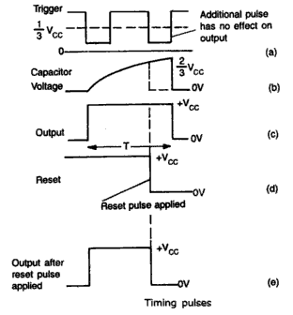

- Explain the working of Schmitt Trigger. (AU-Apr/May 2017)

- Schmitt Trigger is an inverting comparator with positive feedback. It converts sinusoidal input into square wave or pulse output. The output of Schmitt trigger swings between Upper Threshold voltage and Lower Threshold voltage, the reference voltages of input waveform. It is also called as squaring circuit.
- The inverting Schmitt trigger circuit shown in fig
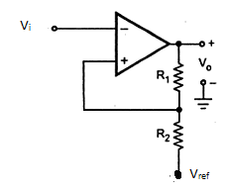
- Input is applied to the inverting terminal of the Op-Amp. The inverted output is feedback to the non-inverting terminal which is in same polarity as that of the output. This ensures positive feedback.

- When V_{in} is slightly positive than V_{ref}, V₀ becomes – V_{sat.} When V_{in} is slightly more negative than V_{ref,} V₀ becomes + V_{sat.}

- The voltage at which the transition takes place is decided by R₁ and R_{2.}

- + V_{ref} is for positive saturation when V₀ = +V_{sat} and is called upper threshold voltage
V_{UT)}.
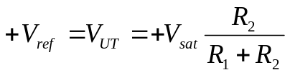 --------------- (1)
- -V_{ref} is for negative saturation, when V₀ = -V_{sat} and is called lower threshold voltage
(V_{LT).}
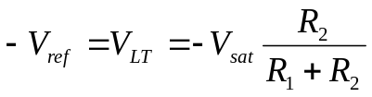 --------------- (2)
- The output voltage remains in a given state until the input exceeds the threshold
voltage either positive or negative.
- Once the output changes its state, it remains there indefinitely until the input voltage (V_{i}) crosses any of the threshold voltage levels. This is called Hysteresis of Schmitt Trigger. The Hysteresis is also called as Dead band or Dead zone.

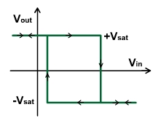
- The difference between two threshold voltages V_{UT} and V_{LT} is called Hysteresis Width (H).
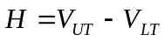 ---------------- (3)
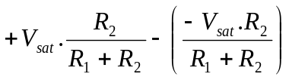 from (1)&(2)
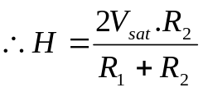 --------------- (4)
- Schmitt Trigger eliminates the effect of noise voltage present in the input.

- The noise voltages less than the Hysteresis, (H) cannot cause triggering.

- From input and output waveforms, we observe, when V_{in} is greater than +V_{ref} or V_{UT},
the output becomes -V_{sat}.

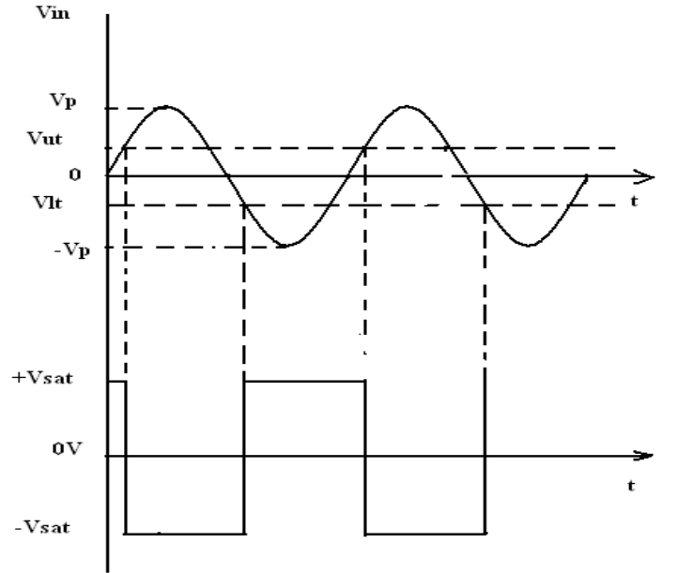
- When V_{in} is less than V_{LT}, the output becomes +V_{sat.} i.e.,
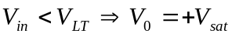
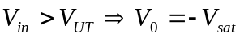
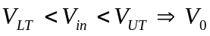 (Previous state achieved.)
- For non-inverting Schmitt trigger the V_{i} and V_{ref} are just interchanged.

APPLICATION:
- The important application of Schmitt Trigger is the conversion of a very slowly varying input voltage to a square wave output (Sine to square wave converter).

- With necessary diagrams explain how op-amp can be used as a triangular wave generator. (AU-May/Jun-2012)
- A triangular wave can be simply obtained by integrating a square wave. The frequency of square wave and triangular wave is the same.

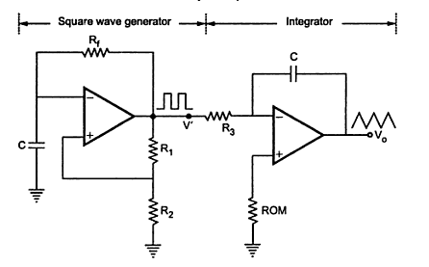

- The amplitude of square wave is constant at V_{sat}. But the amplitude of triangular wave decreases as the frequency increases. This is because the reactance of capacitor C, connected in the integrator decreases at high frequencies.

- Another triangular wave generator with lesser number of components,

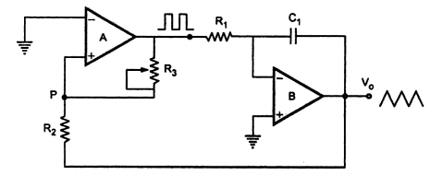

- This basically consist of two level comparator followed by the integrator. The output of the comparatorA₁ is the square wave of amplitude ±V_{sat} and is applied to the (-) input terminal of the integrator A₂ producing a triangular wave. This triangular wave is fed back as input to the comparator A₁ through voltage divider R₂R₃.
- If A₁ is at +V_{sat} then output of the integrator is negative going ramp.at a time t=t₁ when the negative going ramp attains a value of –V_{ramp},the effective voltage at point P becomes less than 0V.This switches the output of A₁ from +V_{sa}t to –V_{sat}.
- When the output A₁ is at -V_{sat} the output A₂ increases in the positive direction. at time t=t₂ the voltage at point P becomes just above zero, there by switching the output from -V_{sa}t to +V_{sat.}

Output wave form of triangular wave generator
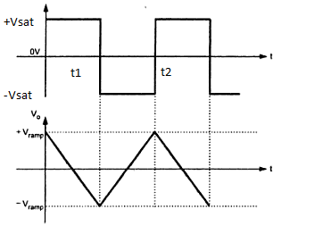
- The effective voltage at point P, when output of A1 is at +V_{sat} is
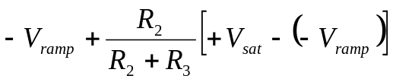 ----------- (1)

- At t = t₁, the voltage at P becomes zero,
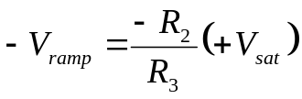 ----------- (2)
- Similarly at time t = t₂, when o/p of A₁ switches from t = -V_{sat} to +V_{sat,}

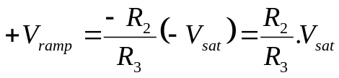 ----------- (3)
- Peak to peak amplitude of triangular wave is

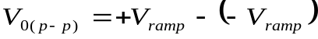 (3) - (2).
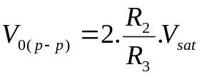 ----------- (4)
- Output switches from -V_{ramp} to +V_{ramp} in time period T/2. Putting the values in basic integrator equation, we get.
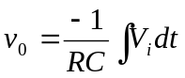
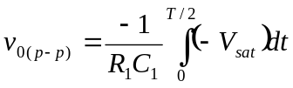
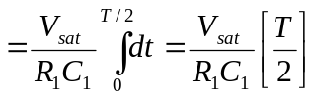
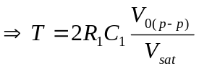
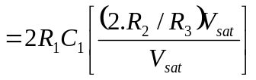 from equation (4)
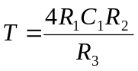
-------------- (5)

Hence the frequency of oscillation is
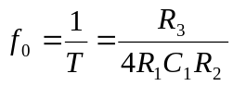

With the help of neat internal function diagram, explain the working of IC 555 as a astablemultivibrator. (May/June16)

- The device is connected for Astable mode of operation is shown below.

- Comparing with monostable operation, the timing resistor is now spitted into two sections R_{A} and R_{B}. Pin 7 of discharging transistor Q₁ is connected to the junction of R_{A} and R_{B}.
- When the power supply V_{CC} is connected, the timing capacitor C charges towards V_{CC} with time constant (R_{A}+R_{B}) C. During this time output (pin 3) is HIGH (V_{CC}) as reset R=0, Set S=1 and this combination makes Q =0 which has unclamped the timing capacitor C.
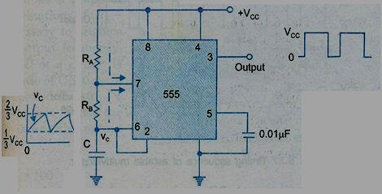

- When the capacitor voltage is just greater than ² ₃ V_{CC} the upper comparator triggers the upper flip-flop so that Q =1. This in turn, makes transistor Q₁ ON and capacitor C starts discharging towards ground through R_{B} and Q₁ with s time constant R_{B}C.
- Current also flows into the transistor Q₁ through R_{A}. Resistors R_{A} and R_{B} must be large enough to limit this current and prevent damage to the Q₁.

Ø The minimum value of R_{A} is approximately equal to where 0.2 A is the current flowing through ON transistor Q_{1.}
- During the discharge of timing capacitor C, when its value is just less than ¹₃ V_{CC} , the lower comparator is triggered and at this stage S=1, R=0, which turns Q =0. Now

capacitor C is unclamped. Thus capacitor charges and discharges periodically between ² ₃ V_{CC} and ¹₃ V_{CC} .
- The length of the time that the output remains HIGH is the time for the capacitor to charge from ¹₃ V_{CC} to ² ₃ V_{CC} . It is calculated as follows:


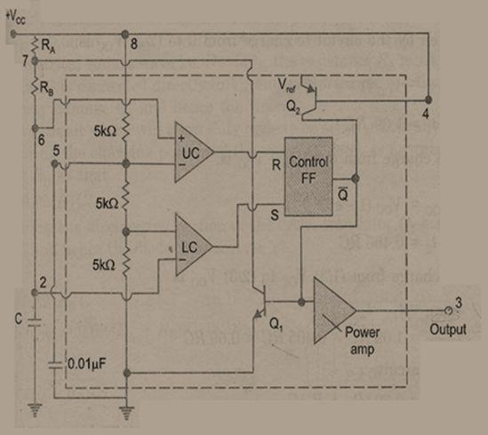

Fig: Functional diagram of astablemultivibrator using 555 timer.
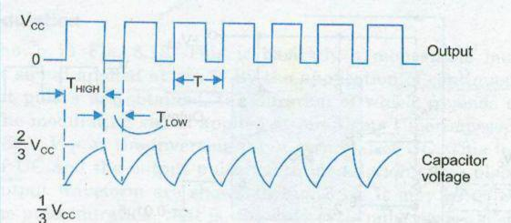

Fig: Timing sequence of astablemultivibrator
- The capacitor voltage for a low pass RC circuit subjected to a step input of V_{CC} is given by,

V _{C} = V _{CC} (1 - e ⁻ ^{t} / ^{RC} )
- The time taken by the circuit to charge from 0 to ² ₃ V_{CC} is

\²_{3/}V_{CC} =V_{CC}(1-e^{-t}1/ ^{RC})

t₁ = 1.09 RC

t₂ = 0.405 RC

Ø So the time to charge from ¹₃ V_{CC} to ² ₃ V_{CC} is,

T HIGH = t1 – t2

T _{HIGH} = 1.09 RC - 0.405 RC = 0.69RC So for the given circuit,

T _{HIGH} = 0.69(R_{A}+R_{B}) C

- The output is LOW while the capacitor discharges from ² ₃ V_{CC} to ¹₃ V_{CC} , and the voltage across the capacitor is given by,

\¹₃V_{CC} =²₃V_{CC}(e^{-t} / ^{RC})

Solving we get,

t = 0.69 RC

So for the given circuit,

T_{LOW} = 0.69R_{B}C

- Resistors R_{A} and R_{B} are in charging path and R_{B}is in discharging path. Therefore the total time is given by,

- = THIGH + TLOW

  - 0.69(R_{A}+R_{B}) C + 0.69R_{B}C

  - 0.69(R_{A}+2R_{B}) C

f = | 1 | = | 1.45
f = | T | = | (R_{A} + 2R_{B} )C
- The below figure shows the various combinations of (R_{A}+2R_{B}) and C necessary to produce the given time delay.

- The Duty cycle (D) of a circuit is defined as the ratio of ON time to the total time period, T = T_{ON} +T_{OFF}

Write short notes on Low Pass Filter. (Or) Explain in detail the design of and operation of First order LPF (May/June-16)
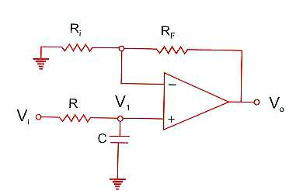

- The Ist order LPF is realized by using RC cirucit. Along with Op-amp in non-inverting configuration. It is also called one-pole low pass Butterworth filter.

- Resistors R₁ and R_{F} decide the gain of the filter in the pass Band.

- The voltage v₁ across capacitor C₁ in s-domain is,

V₁ (s) = | ⎡ | 1/ sC | ⎤
V₁ (s) = | ⎢ |  | ⎥^{.V}i | (s)
 | ⎣ R +1/ sC ⎦

⇒ |  | V₁ (s) |  | = |  |  |  |  |  |  | 1/ sC |  |  |  | = |  |  | 1 |  |  |  |  |  | --------------- (1)
 |  |  |  |  |  |  |  |  |  | R +1/ sC |  |  |  |  |  |  | sRC +1
 |  | V_{i} (s)
The closed loop gain of Op-amp is
 | ^{A}CL |  | = |  |  |  | V₀ |  |  |  | ( s) |  |  | = 1 + |  |  |  |  |  |  | Rf |  |  | --------------- (2)
 |  |  |  |  |  |  | ^{V}1 |  |  |  |  |  |  |  |  |  |  |  |  |  | ^{R}1
 |  |  |  |  |  |  |  |  |  |  | ( s)
So, overall transfer function from equations (1) & (2) is given as,
H (s) = | V₀ (s) |  | = |  | V₀ |  |  |  |  | (s) |  | × | V₁ (s) |  |  | = |  |  |  |  | ^{A}CL |  |  | --------------- (3)
H (s) = | V_{i} (s) |  |  |  | V₁ |  |  |  |  |  |  | × |  |  |  |  |  | 1 + sRC
 |  |  |  |  |  |  |  |  | (s) V_{i} (s)

Let ω_{h} = 1/ RC
∴H (s) = |  |  | ^{A}CL |  |  |  |  | = | ω_{h} .A_{CL}
 |  |  | + s /ω_{h} |  |  |  |  | = | (s +ω _{h} )
1
 | H (s) = |  |  |  |  | ω_{h} |  | .A_{CL} |  |  |  | --------------- (A)
 |  |  |  |  |  | (s + ω_{h} ) |  |  |  |  |  | --------------- (A)
This is the transfer for f 1st LPF.
FREQUENCY RESPONSE:
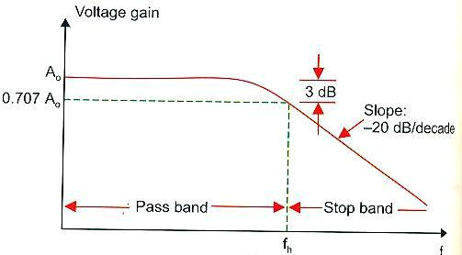

To determine the frequency response, put s = jω in equation (3)
 |  | ⇒ H ( jω) = |  |  |  |  |  |  |  |  |  |  |  |  | ^{A}CL |  |  |  | = |  |  |  |  |  | ^{A}CL |  |  |  |  |  | ---------------- (B)
 |  |  |  |  |  |  |  |  |  |  | 1 + jωRC |  |  |  |  |  |  |  |  |  |  |  |  |  |  | ⎛ |  | f | ⎞ |  | ---------------- (B)
 |  |  |  |  |  |  |  |  |  |  |  |  |  |  |  |  |  |  |  |  | 1 + |  |  |  |  | j⎜ |  | f | ⎟
 |  |  |  |  |  |  |  |  |  |  |  |  |  |  |  |  |  |  |  |  |  |  |  |  |  | ⎜ |  |  | ⎟
 |  |  |  |  |  |  |  |  |  |  |  |  |  |  |  |  |  |  |  |  |  |  |  |  |  | ⎝ |  | fh ⎠

- At very low frequencies, f << f_{h} ; it has maximum gain.
s, f>>f_{h} ;

10. Explain with neat diagram for Logarithmic and antilogarithmic Amplifier.(APR/May 18)
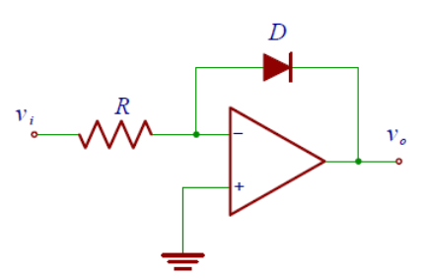
Figure 3.12 shows an elementary logarithmic amplifier implementation whose output is proportional to the logarithm of the input. Let’s analyze this non-linear amplifier in more detail.
The Op-Amp is mounted as an inverting amplifier, and therefore if V_{i}
is positive, then vo must be negative and the diode is in conduction. The diode characteristics is
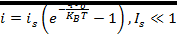
where q < 0 is the electron charge.
Considering that
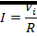
After some algebra we finally get
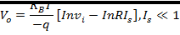

The constant term In (RI_{s}) is a systematic error that can be measured and subtracted at the output. It is worth to notice that v_{i} must be positive to have the circuit working properly. An easy way to check the circuit is to send a triangular wave to the input and plot v_{o} versus v_{i}. Because the BJT collector current Ic versus VBE is also an exponential curve, we can replace the diode with an NPN BJT as shown in Figure 3.12. The advantage of using a transistor as feedback path is that it should provide a larger input dynamic range. If the circuit with the BJT oscillates at high frequency, a small capacitor in parallel to the transistor should stop the oscillation

Anti-Logarithmic Amplifier
Figure 3.13 b shows an elementary anti-logarithmic amplifier, i.e. the output is proportional to the inverse of logarithm of the input. The current flowing through the diode is
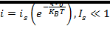
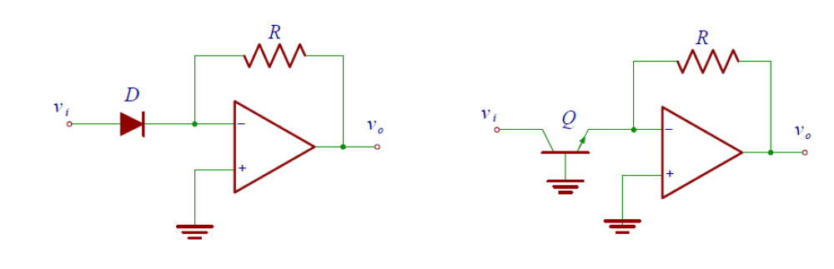

Figure 3.13a&b Anti-Logarithmic Amplifier Circuits

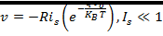
If the input vi is negative, we have to reverse the diode’s connection. In case of the circuit of Figure 3.13(b) we need to replace the PNP BJT with an NPN BJT. Same remarks of the logarithmic amplifier about the BJT, applies to this circuit.
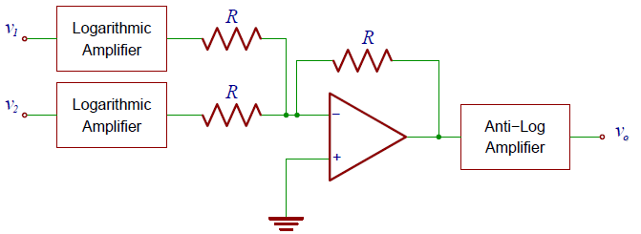
Figure 3.13: Analog multiplier implementation using log and anti-log amplifiers

